Git Workflow for Shopping Project (Multiple Developers)

Developer1 : K. Gopichand
Developer2 : R. Vasanth Singh

1. One student creates a repository named shopping-project.
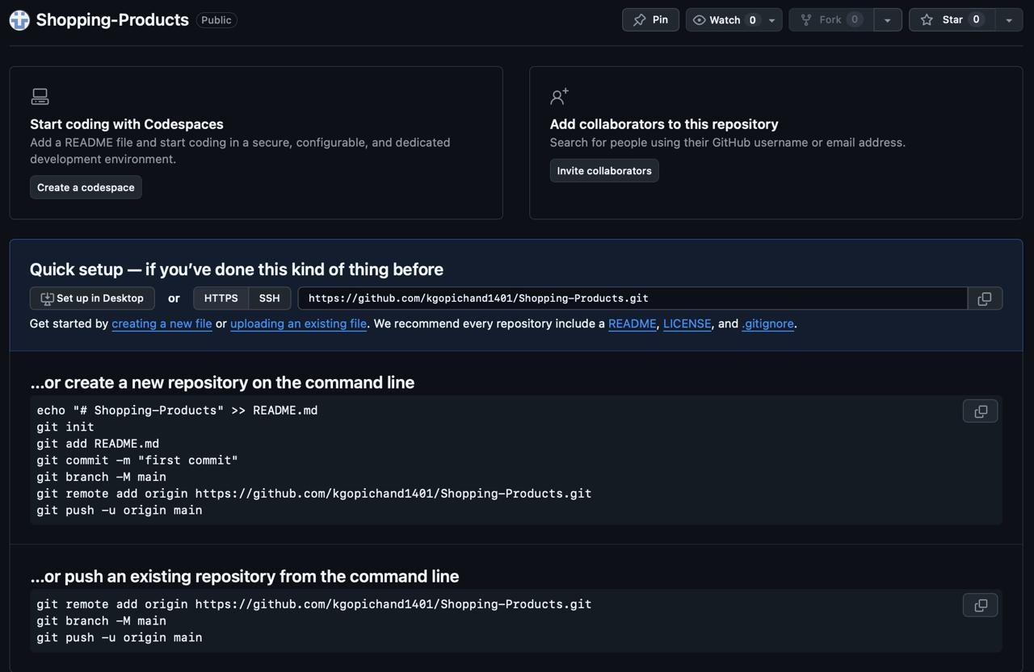

2.Add other team members as collaborators.
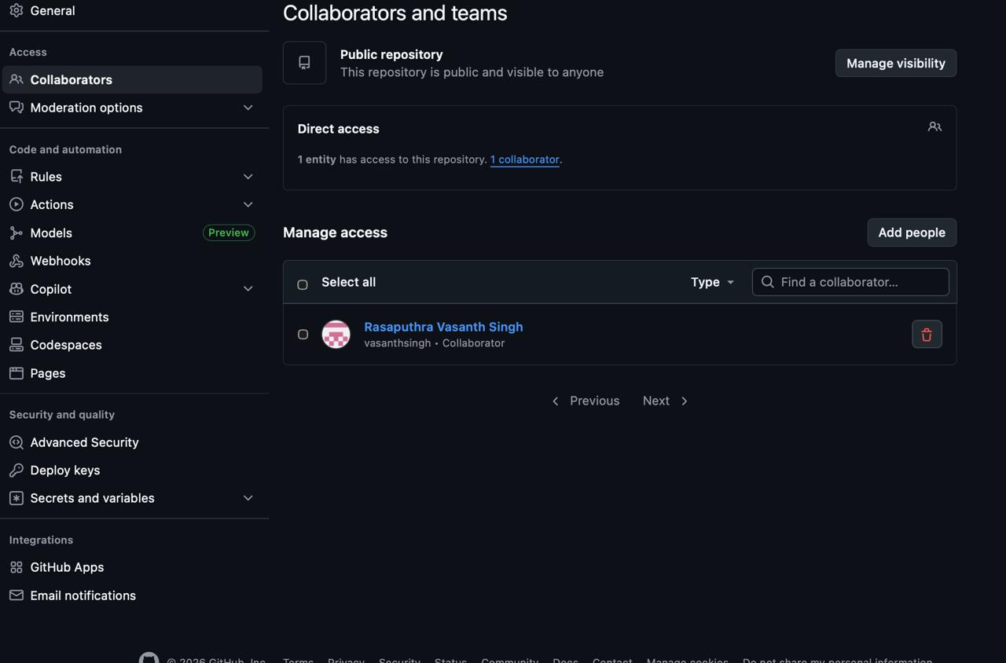
3. All members clone the repository to their local systems

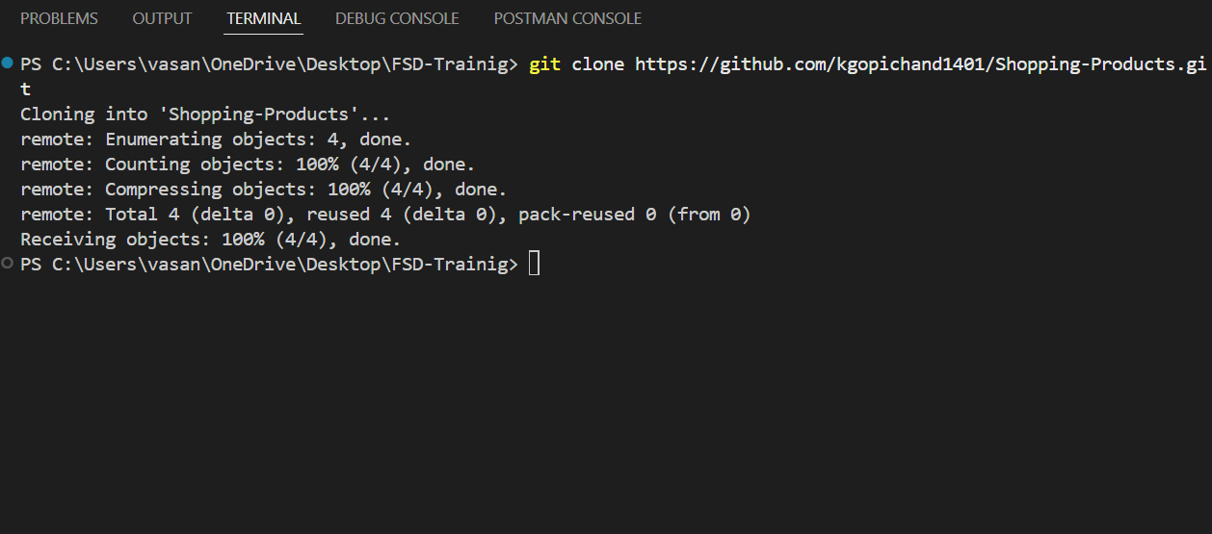

Part A: Initial Setup (Developer 1)
4. Create files:products.txtorders.txt
5. Add initial product data.
6. Commit and push to main.
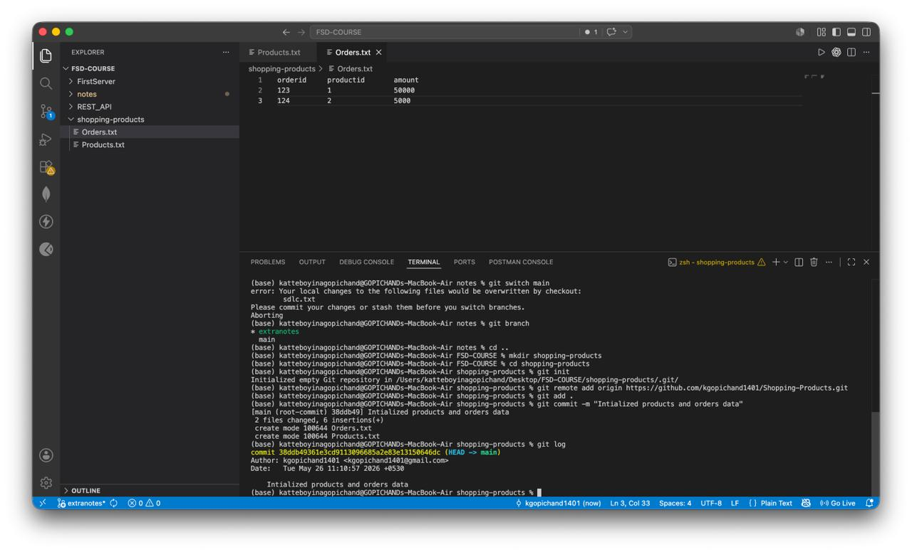
Developer 2: Product Updates
7. Create branch add-products.
8. Add at least 3 new products to products.txt.
9. Commit and push changes.
10. Create a Pull Request.
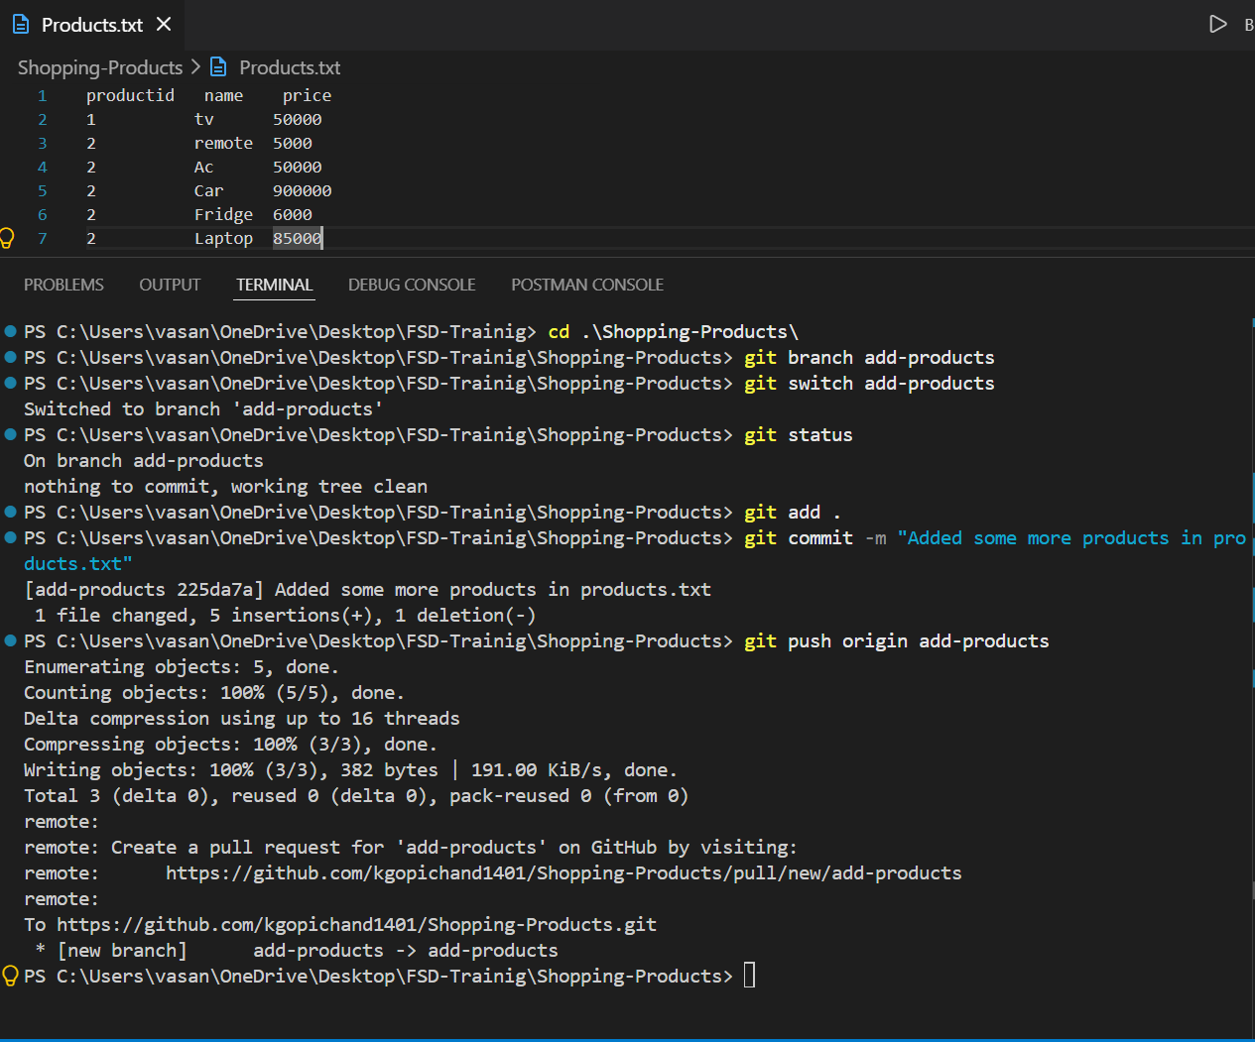
Developer 3: Order Updates
11. Create branch update-orders.
12. Add sample order entries in orders.txt.
13. Commit and push changes.
14. Create a Pull Request.
Part C: Merge & Conflict Handling
15. Merge both Pull Requests into main.

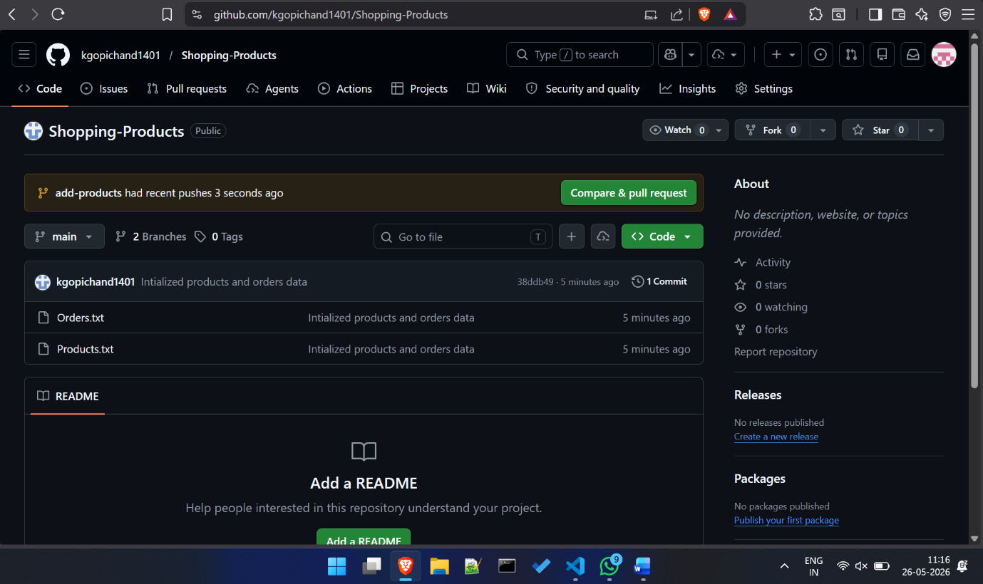16. If co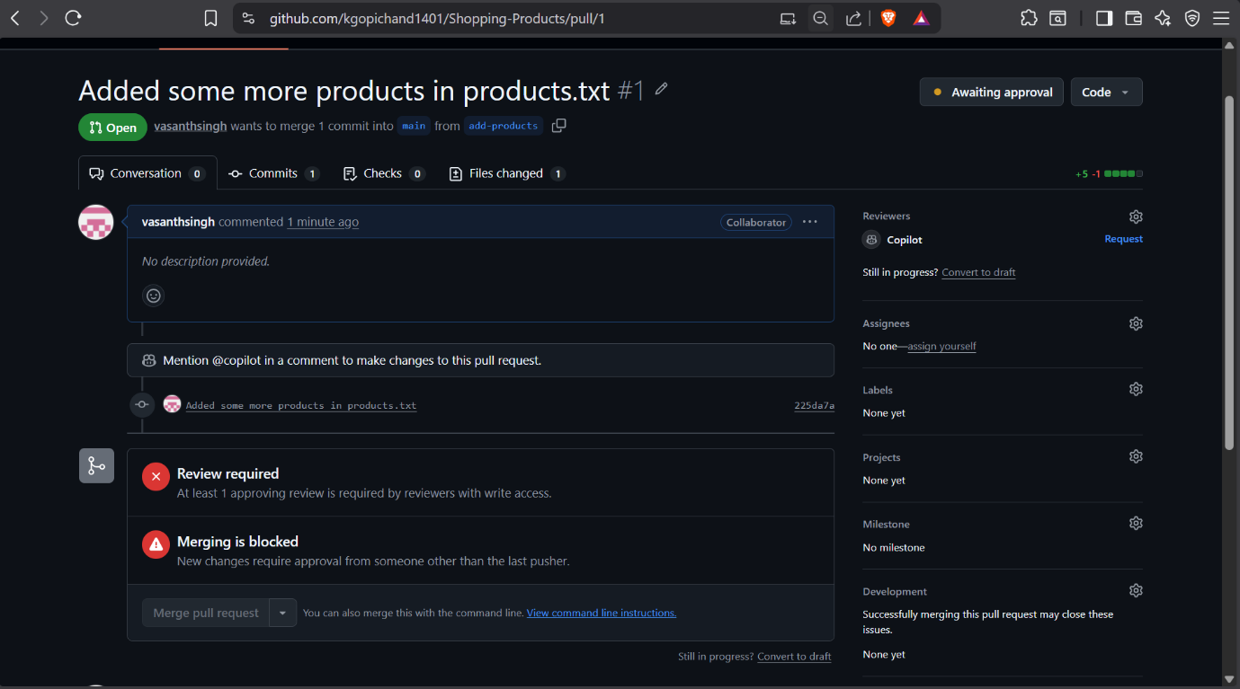
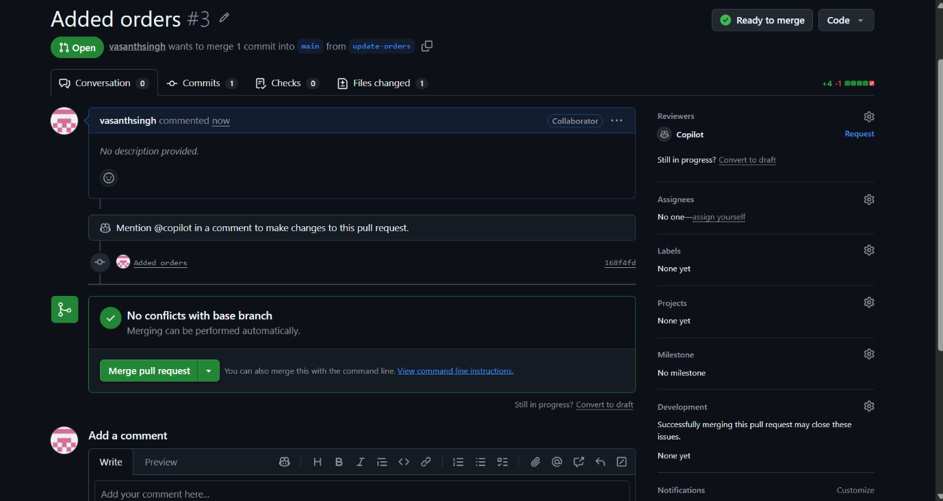

Resolved a merge conflict:

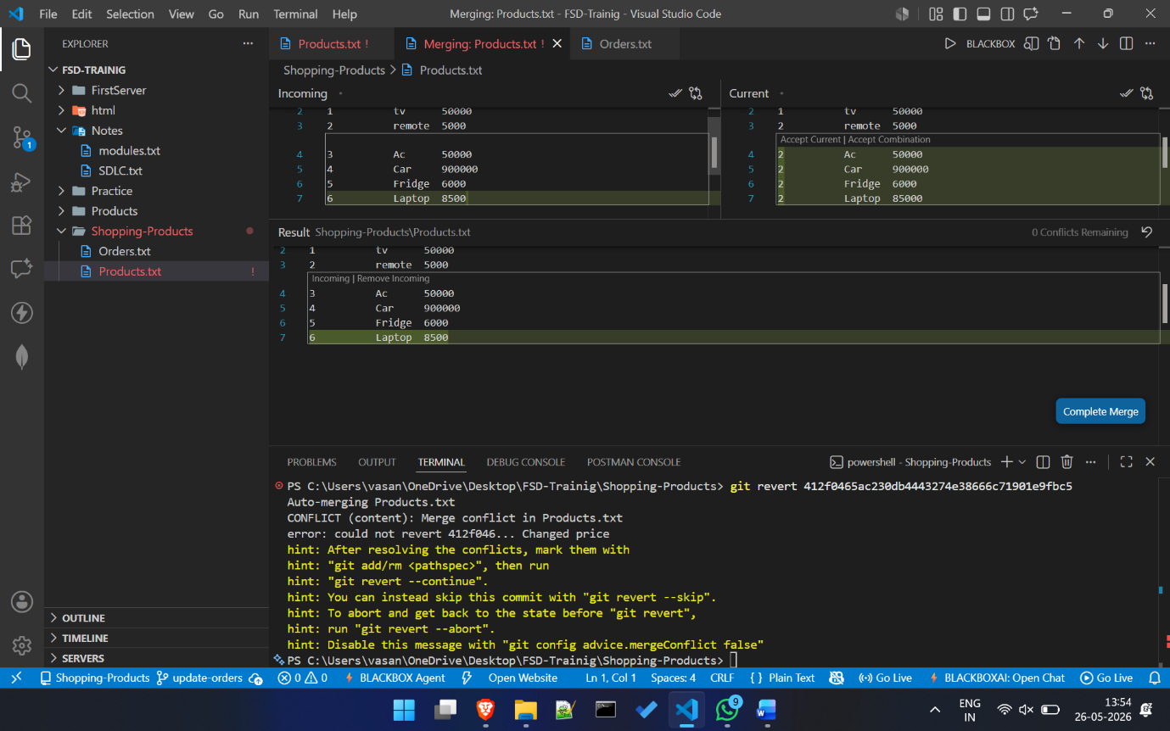

Part D: Reset & Revert
17. One developer makes an incorrect commit.
18. Use git reset to undo the last commit (local change).
19. Make a valid commit again.
20. Use git revert to undo a commit while preserving history.

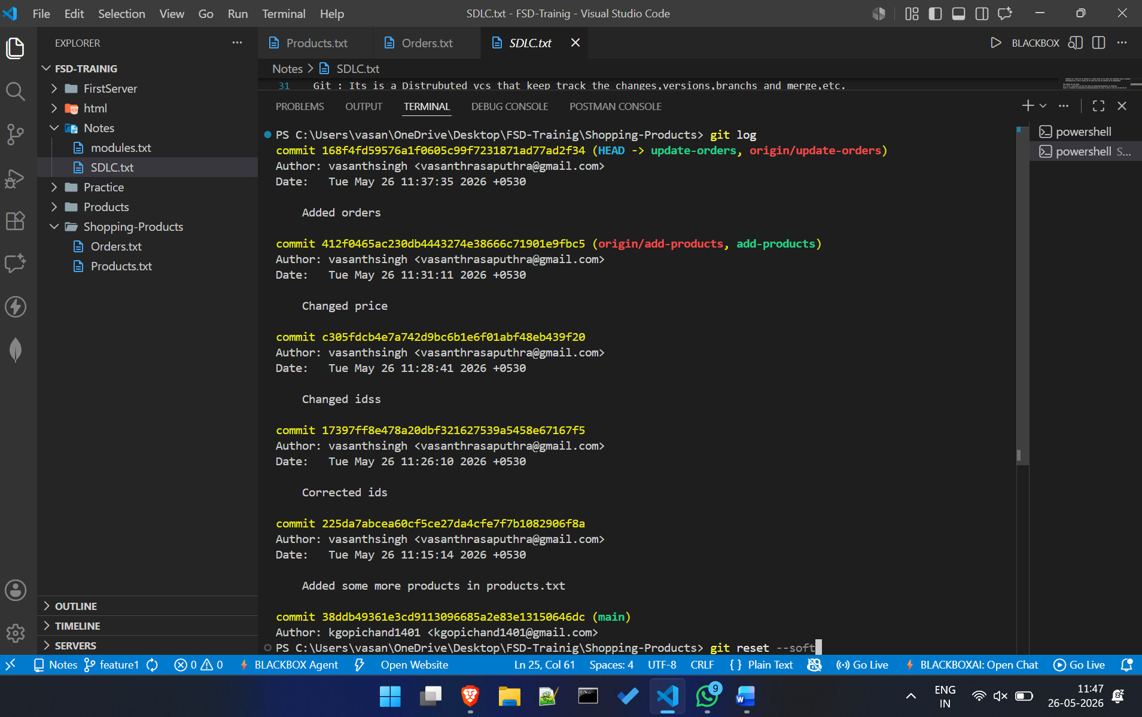

Reset – soft
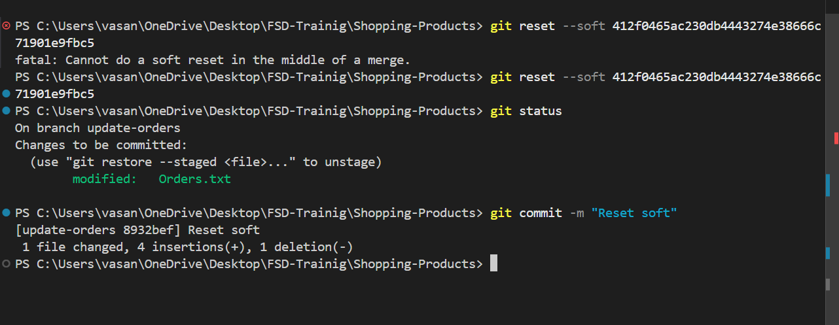
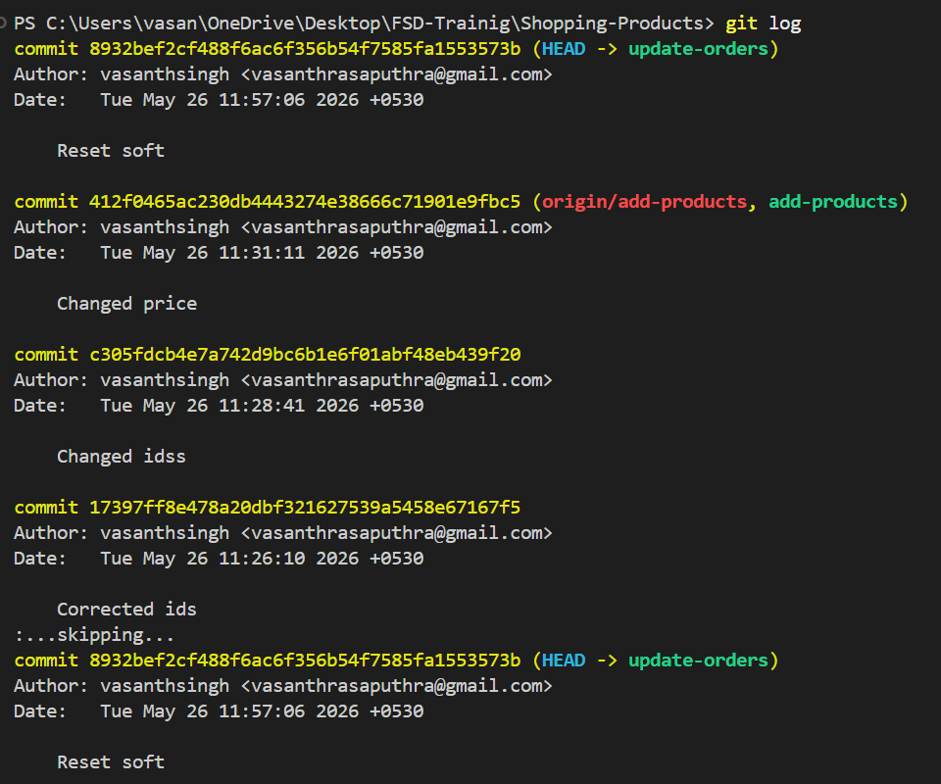

Reset -- mixed
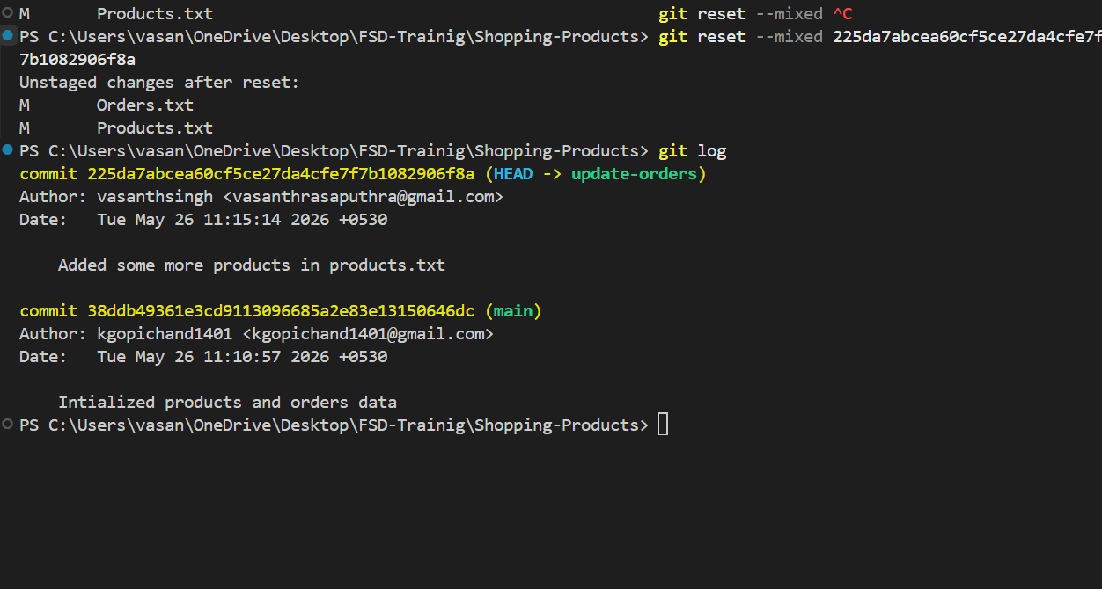

Reset --hard

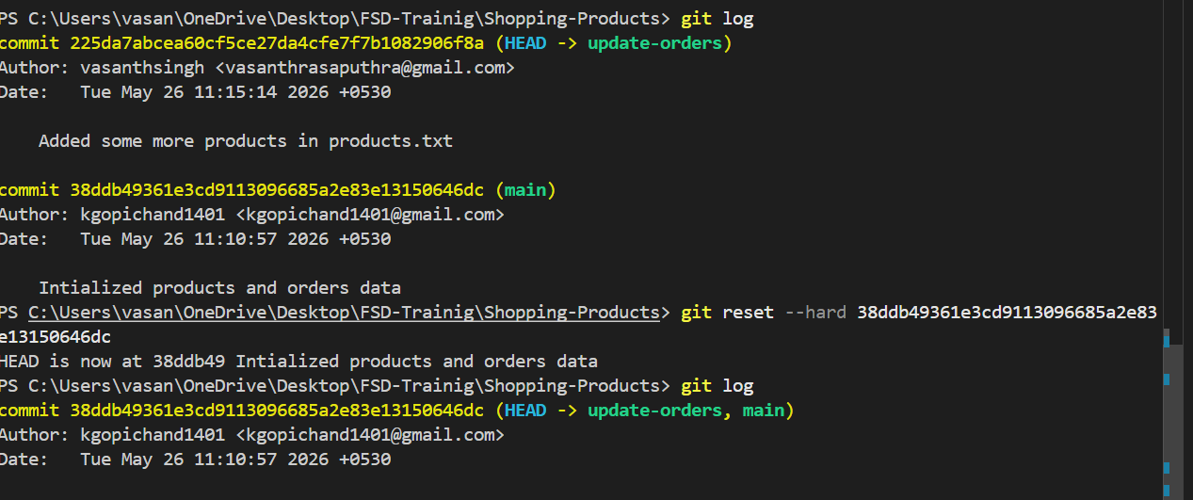

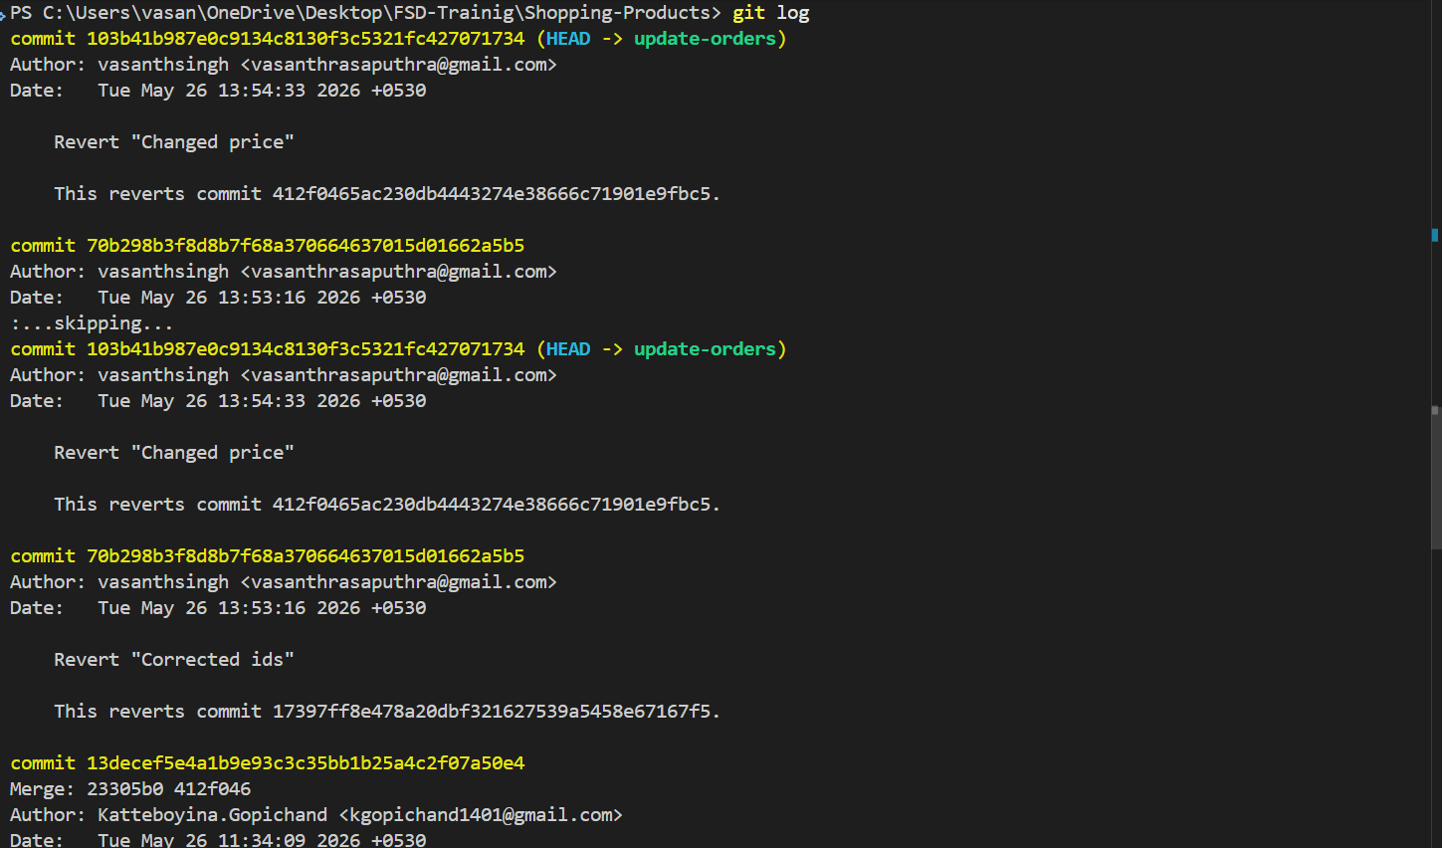

Revert:
